St Peter’s College
Mobility Print
Mobility print is available to all Staff, Students and Fellows of the college. This allows you to connect to the college printers from any network and print to the photocopiers at the college.
Please Note: This does NOT apply to Android or iOS Devices
Firstly you need to download the Mobility Print Client which can be done by pressing CTRL + clicking on the link below:
Download SPC Mobility Print Client
Select Step 1 and click on ‘Download and run Mobility Print’ - this will download the file and then run the downloaded file:
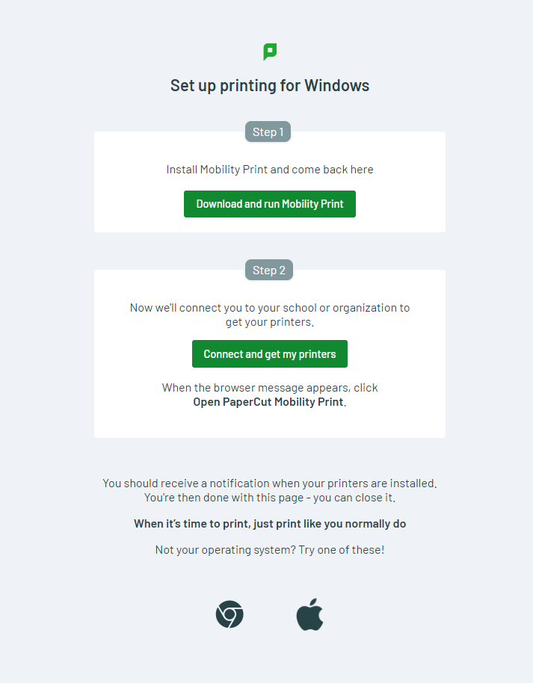

Run the downloaded file
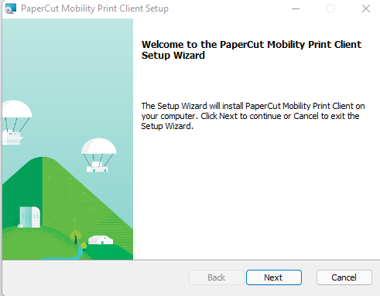

Run through the install by clicking next until clicking on Finish.
Now select Step 2 and click on ‘Connect and get my printers’ - this will create a printer called:

Now you should be able to print your documents to the above printer. When printing you can change the colour of your printout from Mono (Default) to colour by clicking on Printer Properties:
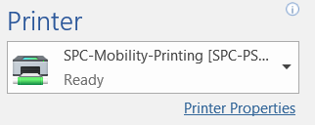

And changing the Colour to either Black & White or Colour (as below)
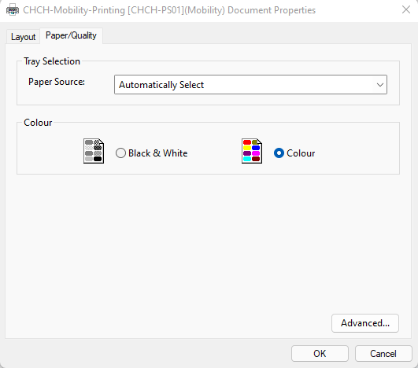
The first time you print you will be asked for you username and password.
- Username will be your College username - spet1234
- Password – college password (same one you use for SPC-Members Wi-Fi)

College passwords can be reset here by clicking on CTRL + clicking on the link below:
https://college-account.spc.ox.ac.uk/
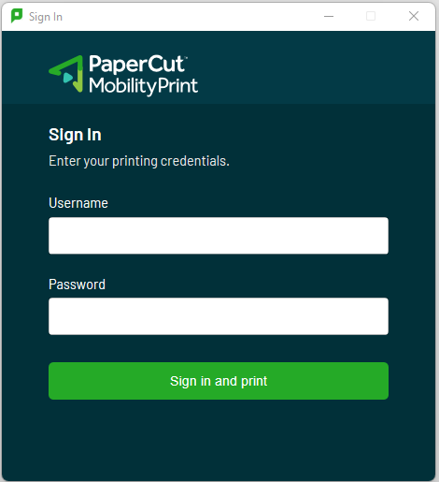
Releasing print jobs on printers
Using your university card – tap on the card reader on the printer:
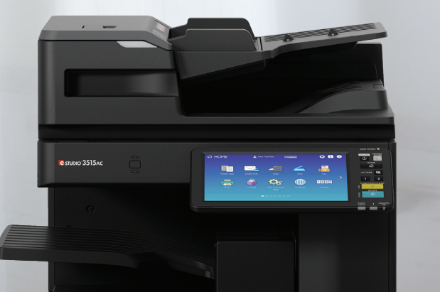
Card Reader

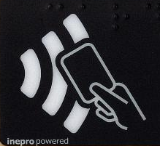
OR
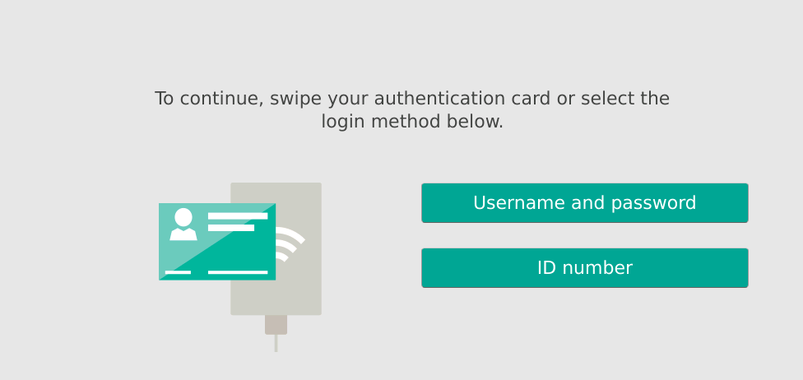
Login using the photocopier screen panel with your College username and College password:

This will authenticate you with the system and allow you to release your print jobs.

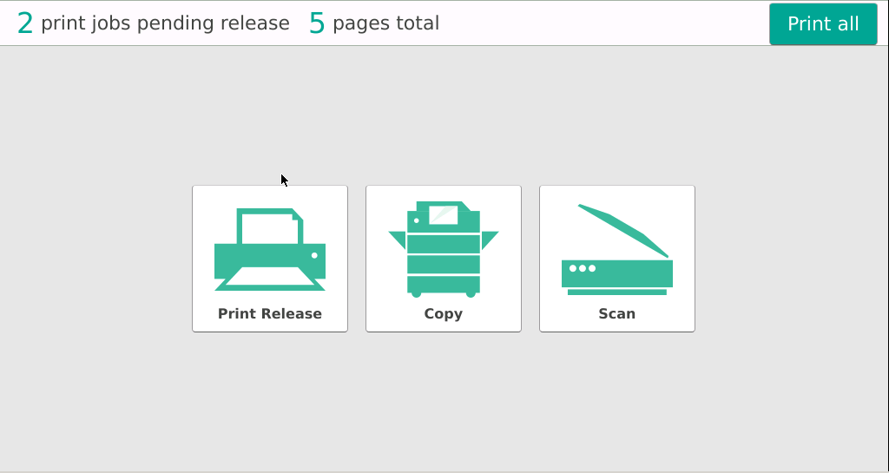
Either click:
- Print All – will release all jobs

- Print Release – Will allow you to pick particular jobs

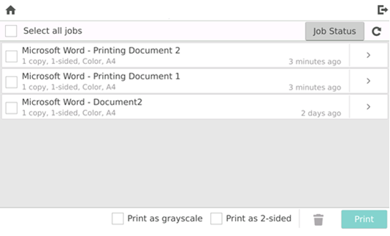

- Copy – copy function
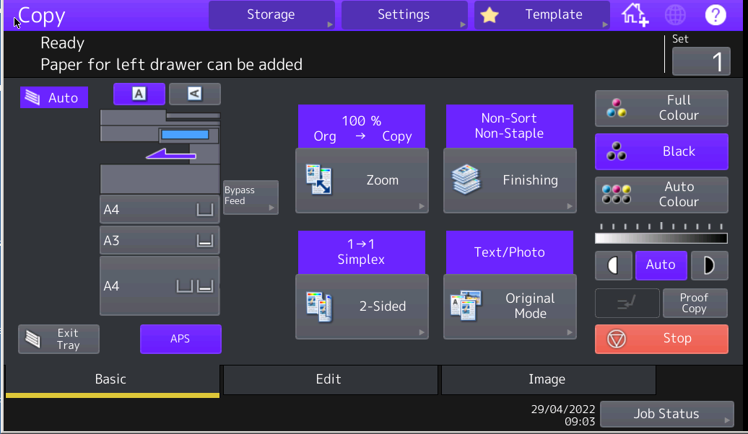

- Scan – scan function – allows you to scan to your university email.
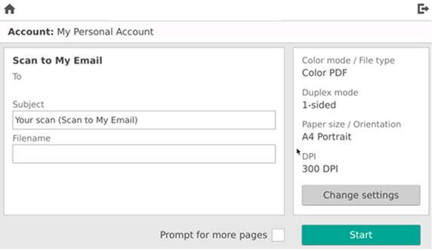

Any issues please contact the IT Helpdesk by sending an email to it-help@spc.ox.ac.uk

