St Peter’s College
Email to Print
Email to print allows users to send an email to a specific email address and release their print jobs securely.
Create an email and sent your email to the following address:
Print.mono@spc.ox.ac.uk (Black + White Printing)
Print.colour@spc.ox.ac.uk (Colour Printing)

Students can now release your print out on any of the following printers:
Staircase 2 Corridor
Staircase 3 Corridor
Staircase 4 Corridor
Library
Releasing print jobs on printers
Using your university card – tap on the card reader on the printer:
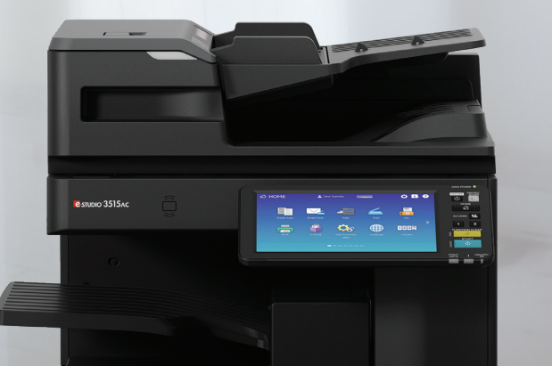
Card Reader

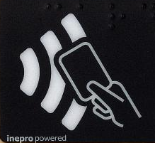
OR
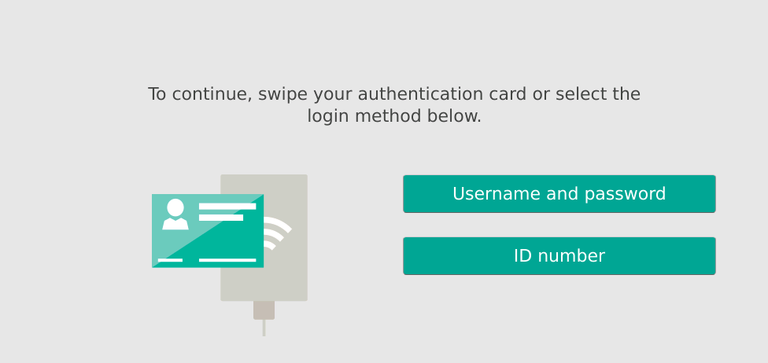
Login using the photocopier screen panel with your College username and College password:

This will authenticate you with the system and allow you to release your print jobs.

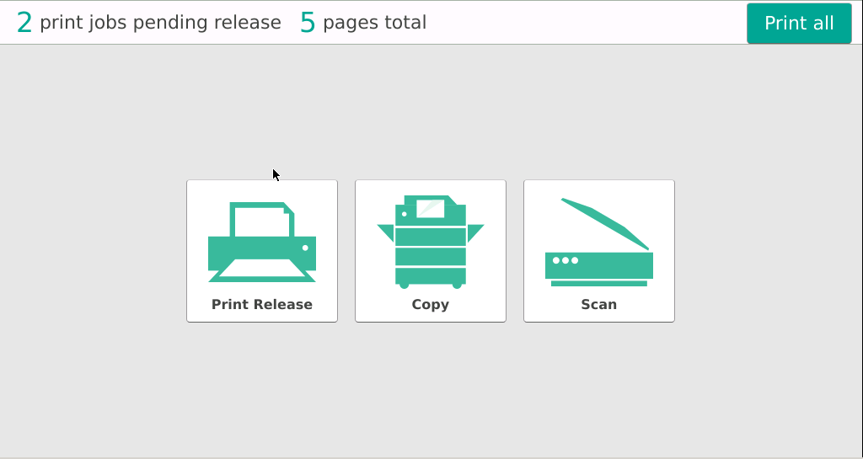
Either click:
- Print All – will release all jobs

- Print Release – Will allow you to pick particular jobs

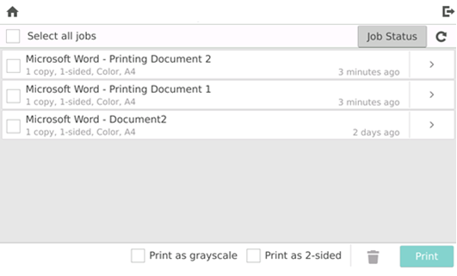

Any issues please contact the IT Helpdesk by sending an email to it-help@spc.ox.ac.uk

