 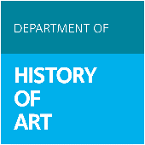

**BA History of Art Students Welcome & Induction Morning**

**Thursday 9 October (Week 0) Michaelmas Term 2025**

**Department of History of Art**

**Schwarzman Centre for the Humanities, Oxford, OX2 6AH**

__________________________________________________________________

10.30am-10.45am Welcome by Professor Geoff Batchen, Head of Department, and introductory welcome by staff and student reps.

Room 20.501 (History of Art Seminar Room)

# 10.45-11.30am Introductory cohort meeting for the 1st year courses (Dr Marko llić and Professor

# [Charlene Villaseñor Black](https://www.hoa.ox.ac.uk/people/professor-charlene-villasenor-black), Co-Prelims Coordinators)

Room 20.501

11.45am-12pm Introduction to the Careers Service - Callum Buchanan, Careers Lead for Creative

Careers, University of Oxford

Room 20.501

*LUNCH BREAK (not provided)*

2pm-2.15pm Introduction to languages for History of Art Students (presented by Tutors from the Language Centre)

Room 20.501

*Please note that the schedule is subject to change*